INSY 4305 Lab 4 Instructions

Currency Coversion Program

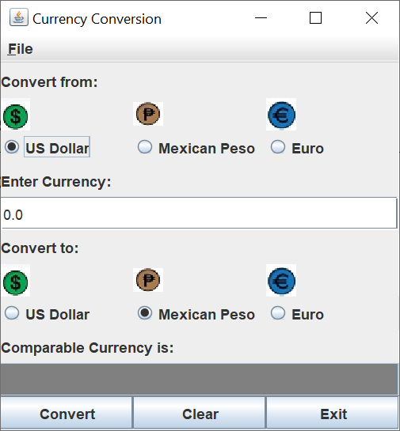

Write a currency-conversion GUI application as shown in the picture. The input currency should be entered from the keyboard (via a JTextField). A read-only JTextField should be used to display the converted currency. Use given images to create curreny icons using JLabels. The application should allow the user to make coversion between any two types.

Use the following webpage for the currency conversion:

[***https://www.oanda.com/currency-converter/***](https://www.oanda.com/currency-converter/)

Please see the follwing sample runs to build your application.

1. From US Dollar to Mexican Peso - Enter 100 and hit Enter Key

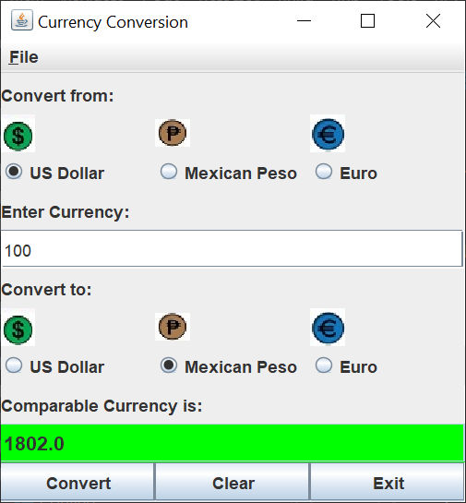

1. From US Dollar to Euro – Enter 200 and Click on **Convert** button

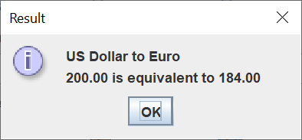

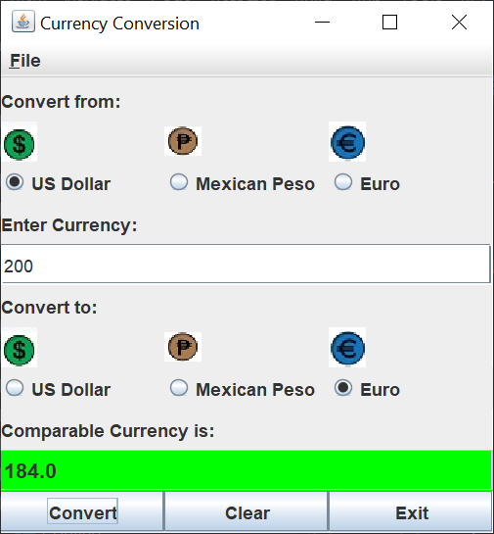

1. From Euro to US Dollar – Enter 20 and click on **Convert** button

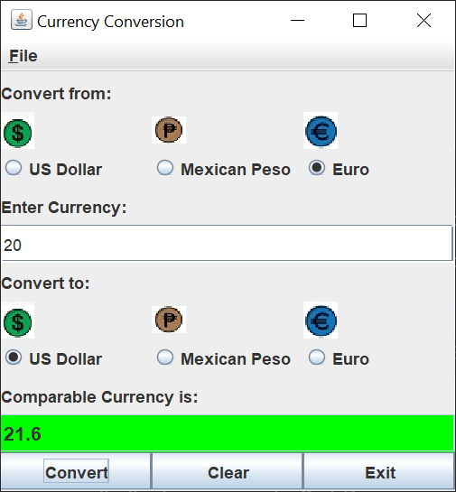

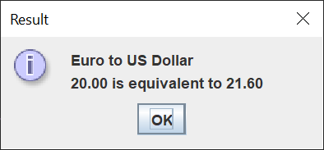

1. Click on **Clear** button

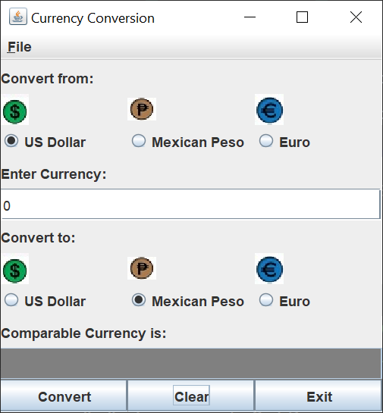

1. Click on **File** menu and click on **About..**

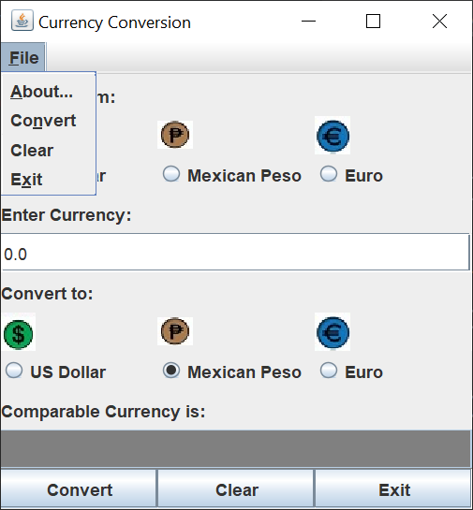

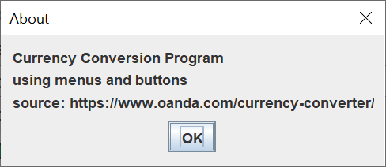

1. **Convert**, **Clear**, and **Exit** menu items must function like the corresponding buttons in the window.
2. Click on **Exit** button

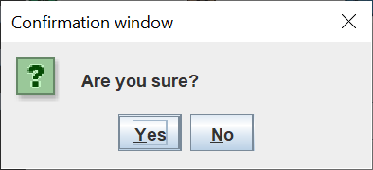

**Resources:**

* Lab_4_Help
* fig26_15_16
* fig35_05_06

Deliverables:

* ConvertFrame.java (60%)
* ConvertApp.java (20 %)
* Screenshot(s) (20%)

Note: Sparingly comment your java source code, save all the files in ***your_lastname_lab_4*** folder, zip it, and upload for grading.

Thank you!

JFrame - GridLayout(11, 1))

|  |
| --- |
| label1 |
| (iconFromPanel with 3 labels) – GridLayout 1 X 3 |
| (fromJPanel - with 3 labels) - GridLayout 1 X 3 |
| (label3) |
| (currencyJTextField1; |
| (label2) |
| (iconToPanel with 3 labels) - GridLayout 1 X 3 |
| (toJPanel with 3 labels) - GridLayout 1 X 3 |
| (label4) |
| (currencyJTextField2) |
| (buttonPanel with 3 buttons) - GridLayout 1 X 3 |

